

**Java Institute for Advanced Technology**

UNIT NAME : OBJECT ORIENTED PROGRAMMING CONCEPTS - I

UNIT ID : H7DY 04

ASSIGNMENT ID : H7DY 04/AS/01

**Name :** Jayaweerage Namindu Wathsala Fernando

**SQA ID :** 207981559

**NIC :** 200133000408

**BRANCH :** Colombo



Contents

**a)** **Use case diagram** 3

**c)** **Sequence diagrams** 4

**d)** **Collaboration diagrams** 5

**f)** **State diagram** 6

# **Use case diagram**

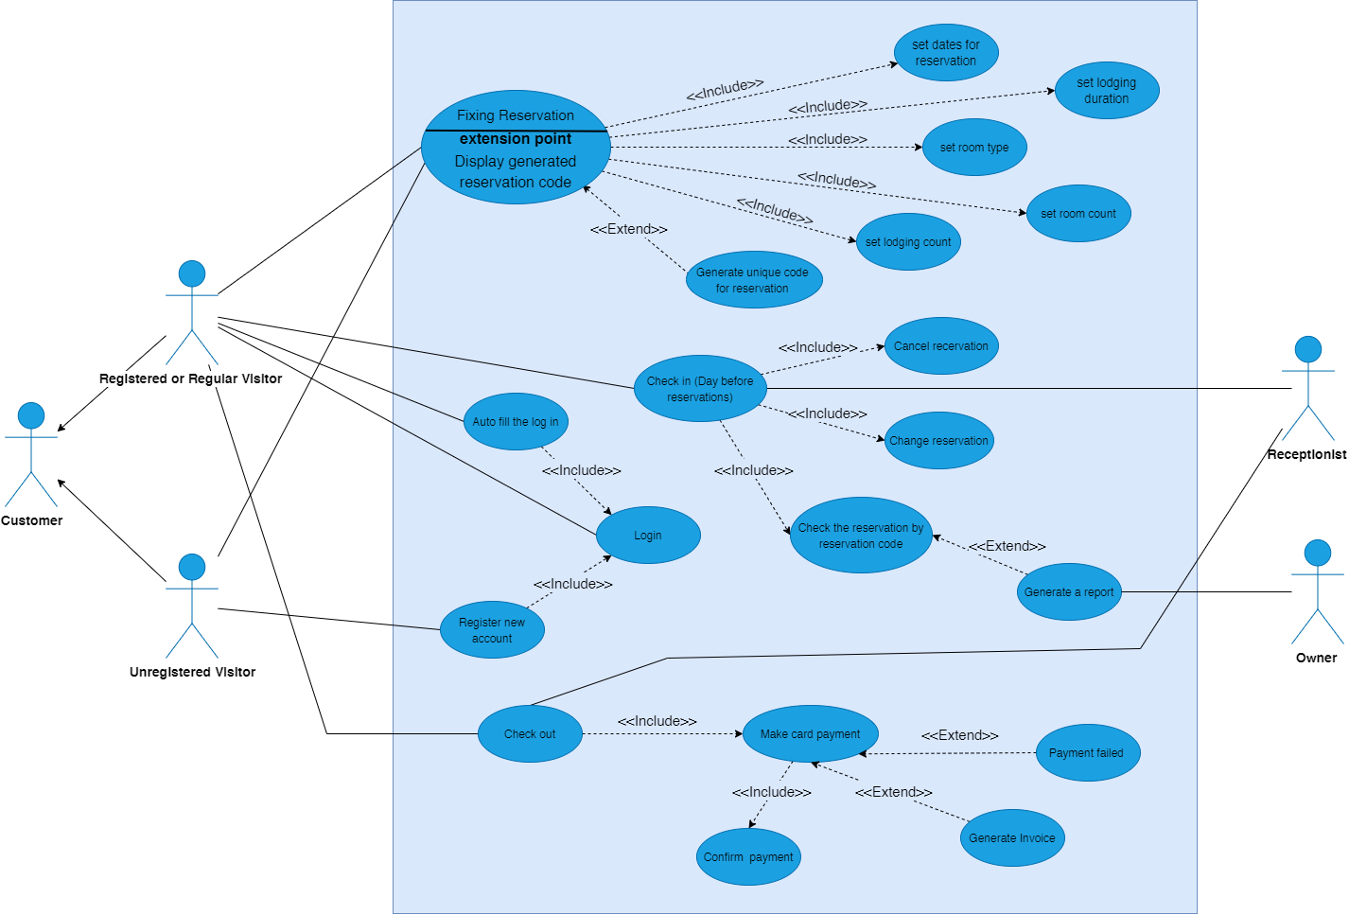

# **Sequence diagrams**

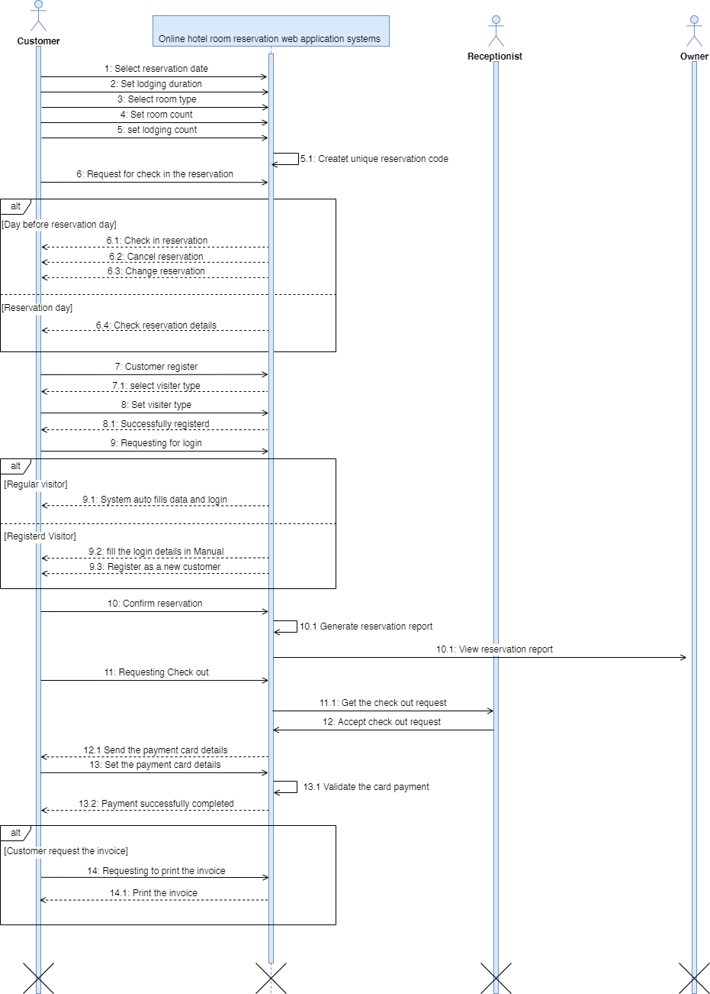

# **Collaboration diagrams**

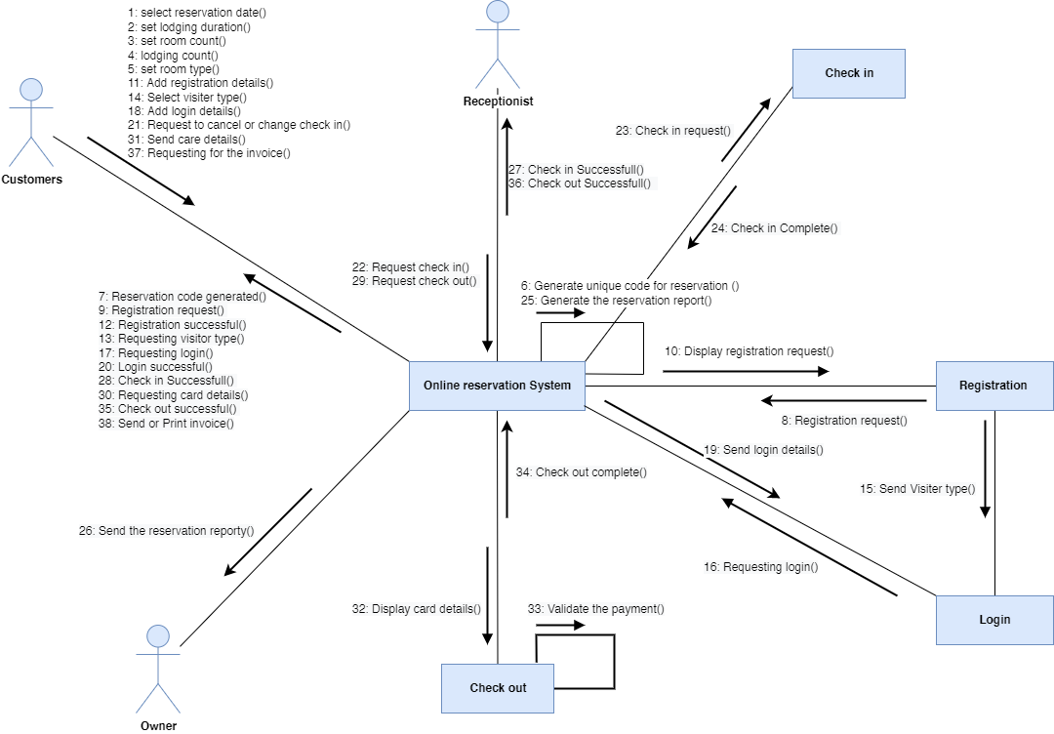

# **State diagram**